- Introduction

Optimization for Data Science’s Homework report

Massimo Andreetta  massimo.andreetta@studenti.unipd.it | Davide Bizzarro  davide.bizzarro@studenti.unipd.it
Elisa Matteligh  elisa.matteligh@studenti.unipd.it | Matteo Pernini  mattero.pernini@studenti.unipd.it

We have a semi-supervised learning task in which we have l labeled examples (x^{i}, y^{i}), i = 1,..., l and u labeled examples (x^{j}, ), j = 1,…, u. Our goal is to obtain y^{j}.

In order to achieve this objective, we define the weights w_{ij} (similarity between the labeled example i and the unlabeled example j) and w_{ij} (similarity between the unlabeled examples i and j).
We then have to minimize the following function:
[ok forse qua LateX è necessario, metti la funzione da minimizzare pls]

For testing we use a randomly generated set of points in 2D in which we give labels only to a small subset of those points. We then choose a proper similarity measure to the define the weights w_{ij} and w_{ij} in order to minimize the previous function, which will be then solved with:
- Gradient Descent
- BCGD with randomized rule
- BCGD with cyclic rule

In both BCGD methods we use blocks of dimension 1.
Finally, we test the methods on a publicly available dataset, analyzing accuracy vs CPU time.

Dataset
We first created our dummy dataset of 10000 samples using the “half-moon” shaped dataset provided by sklearn.
Then, we randomly sampled 200 rows of data to keep labeled, from which we derived, by elimination, the 9800 rows of unlabeled data.

With this information, we then split the dataset in labeled and unlabeled numpy arrays, while also converting the labels from 0/1 to -1/1. We then obtained the 2D coordinates of the points of the two sets and plotted the following graph:

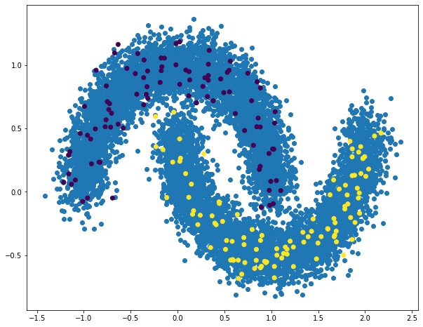
Fig. 1: Blue points: unlabeled data
Purple (-1) and yellow (1) points: labeled data

Finally, for our test dataset we decided to use the Kaggle dataset “Rice type classification" obtained from [1].
This set of data created for rice classification consists in 18185 examples described by 11 numeric features and 1 binary target variable named “Class”. Class 1 is classified as Jasmine rice while Class 0 is classified as Gonen rice.

In order to have a 2-dimensional problem, we remove all the features except 'Area’, ‘Perimeter' and the label variable "Class". The distribution of the data is the following:
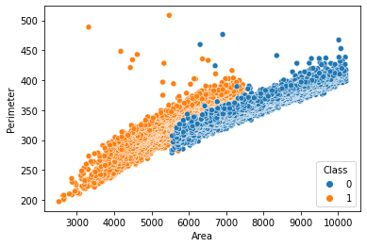
Fig. 2: Distribution of the dataset after removing all the features except “Area” and “Perimeter”
We then used the same process to split 600 labeled and 17585 unlabeled examples into two arrays, from which we derived the following graph:
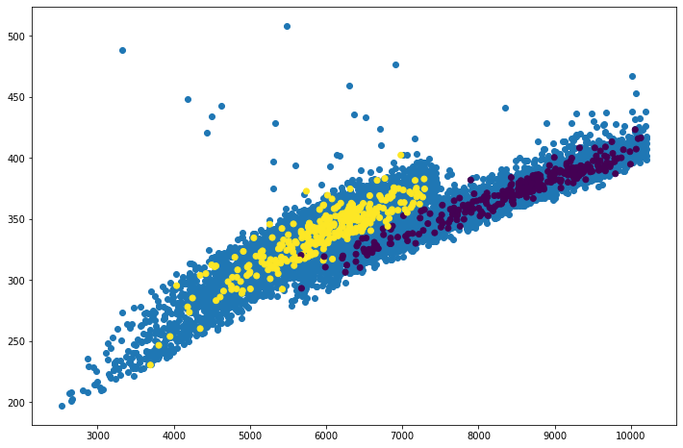
Fig. 3: Blue points: unlabeled data
Purple (now -1) and yellow (1) points: labeled data

- Method

As mentioned before, we decided to create our dummy dataset using sklearn.datasets.make_moons, which was then split into two numpy array, labeled and unlabeled. After that, we calculated the weights w_{ij} and w_{ij} using as similarity function the rbf kernel, with threshold for points too far from each other.
[Continua da qua]

Experiments

References
- Kaggle, https://www.kaggle.com/datasets/mssmartypants/rice-type-classification

